A Project Report
on

“Disease Prediction Using ML-Lung Cancer Detection and Classification Using Efficient Net”
Submitted to the

Savitribai Phule Pune University

In partial fulfillment for the award of the Degree of
Bachelor of Engineering
in
Information Technology
by

Asmita Nalawade

Shraddha Agre

Shubham Malpure

Swapnil Bhalerao
Under the guidance of


Prof. J. S. Kulkarni

Department of Information Technology
STES’s Sinhgad College of Engineering
Vadgaon (Bk.), Off. Sinhgad Road, Pune 411041.
Semester-I Final Year Engineering 2020-2021



CERTIFICATE
This is to certify that the project stage I report entitled ”Disease Prediction Using ML- Cancer detection and classification Using Efficient Net” being submitted by Asmita Nalawade, Shraddha Agre, Shubham Malpure, Swapnil Bhalerao is a record of bonafide work carried out by him/her un- der the supervision and guidance of Prof. J. S. Kulkarni in partial fulfillment of the requirement for BE (Information Technology Engineering) - 2015 Course of Savitribai Phule Pune University, Pune in the academic year 2020- 2021.

Date: 01/04/2021 Place: Pune

Prof. J. S. Kulkarni Dr. S. D. Lokhande Prof. G. R. Pathak
Seminar Guide Principal Head of the Department

This Project Stage I report has been examined by us as per the Savitribai Phule Pune University, Pune requirements at STES’s Sinhgad College of Engineering, Pune-411041 on . . . . . . . . . . .

Internal Examiner External Examiner


CONTENTS
Sr. No. | Names of Contents | Page No.
1 | INTRODUCTION TO DISEASES PREDICTION USING ML –LUNG CANCER DETECTION AND CLASSIFICATION USING EFFICIENT NET
1.1 | GENERAL INTRODUCTION | 6
1.2 | Background | 8
1.3 | Related Work | 9
1.4 | CNN-based Approaches | 9
1.5 | Motivation | 10
2 | LITERATURE SURVEY
2.1 | Introduction | 11
2.2 | Research Papers | 12
2.3 | Summary | 16
3 | RESEARCH METHODOLOGY | 18
3.1 | Aim& Objectives | 18
3.2 | Problem Statement | 18
3.3 | Need for study of Lung Cancer Detection and Classification Using Efficient Net | 18
3.4 | Scope for study of Lung Cancer Detection and Classification Using Efficient Net | 18
3.5 | Methodology | 19
4 | SYSTEM DESIGN
4.1 | System Architecture | 20
4.2 | Algorithm | 21
4.3 | Software & Hardware Requirement Specification | 22
4.4 | Assumptions and Dependencies | 22
4.5 | Project Timeline Chart | 23
5 | UML DIAGRAMS
5.1 | Data Flow Diagrams | 24
5.1.1 | Data Flow Level-0 | 24
5.1.2 | Data Flow Level-1 | 24
5.1.3 | Data Flow Level-2 | 25
5.2 | Class Diagram | 25
5.3 | Activity Diagram | 26
5.4 | Sequence Diagram | 26
5.5 | Work Flow Diagram | 27
5.6 | Use Case Diagram | 27
5.7 | User Interfacing Diagram | 28
6 | DATABASE DESCRITION
6.1 | DATASET | 29
6.2 | Future Scope | 32
6.3 | Advantages & Disadvantages | 32
7 | Code for Prepare , Train ,test and Reshape the module | 33
8 | Implemented Input-Output | 36
9 | CONCLUSION | 41
10 | REFERENCES | 42
LIST OF FIGURES
FIG 1.1 | Efficient Net Performance | 6
Fig1.2 | Model Scalling for CNN | 7
Fig 1.3 | Conversion of Normal CNN to FCN | 9
FIG 5.1.1 | Data Flow Level-0 | 24
FIG 5.1.2 | Data Flow Level-1 | 24
FIG 5.1.3 | Data Flow Level-2 | 25
FIG 5.2 | Class Diagram | 25
FIG 5.3 | Activity Diagram | 26
FIG 5.4 | Sequence Diagram | 26
FIG 5.5 | Work Flow Diagram | 27
FIG 5.6 | Use Case Diagram | 27
FIG 5.7 | User Interfacing Diagram | 28
FIG 6.1 | Architecture of CNN | 29
Fig 6.2 | Polling Layer | 32

ABSTRACT

Lung cancer classification can be identified to the middle aged persons nowadays. Early prediction and classification of cancer stage is mandate to take counter measures to treatment and easy diagnosis. The scanned images are mostly used to obtain the occurrence of lung small cell cancer. In existing techniques used by machine learning traditional techniques and advanced deep learning and Efficient Net B-7 it can classify the cancer occurrence and predict the feasible treatment based on diagnosis. Thresholding was used as an initial segmentation approach to segment out lung tissue from the rest of the scanned images. Thresholding produced the next best lung segmentation. Lung cancer is the leading cancer cause of death and its survival rate is very small. An early diagnosis is a good solution to increase the survival rate for lung cancer. To diagnose lung cancer using EfficientNet we present a convolutional neural network to diagnose three types of lung cancer based on scanned images. The proposed model consists of a main path and three sub-paths. The main path works to extract the small features and creates feature maps at low-level. As for the sub-paths is responsible for transferring the medium and high levels feature maps to fully connected layers to complete the classification process, also the ResNet was prepared to compare it with the performance of the proposed. We use neural architecture search to design a new baseline network and scale it up to obtain a family of models, called EfficientNets. We systematically study model scaling and identify that carefully balancing network depth, width, and resolution can lead to better performance. Based on this observation, we propose a new scaling method that uniformly scales all dimensions of depth/width/resolution using a simple yet highly effective compound coefficient. We demonstrate the effectiveness of this method on scaling up MobileNets and ResNet.

Keywords— EfficientNet,Deep Learning, Convolutional Neural Networks, Lung Cancer Detection, ResNet, MobileNets

CHAPTER 1
INTRODUCTION TO DISEASES PREDICTION USING ML –LUNG CANCER DETECTION AND CLASSIFICATION USING EFFICIENT NET

  - General Introduction
EfficientNet model was proposed by Mingxing Tan and Quoc V. Le of Google Research, Brain team in their research paper ‘EfficientNet: Rethinking Model Scaling for Convolutional Neural Networks’. This paper was presented in the International Conference on Machine Learning, 2019. These researchers studied the model scaling and identified that carefully balancing the depth, width, and resolution of the network can lead to better performance.
Based on this observation, they proposed a new scaling method that uniformly scales all dimensions of depth, width and resolution of the network. They used the neural architecture search to design a new baseline network and scaled it up to obtain a family of deep learning models, called EfficientNets, which achieve much better accuracy and efficiency as compared to the previous Convolutional Neural Networks.

They also presented a comparison of EfficientNet’s performance with other powerful transfer learning models when worked on ImageNet dataset. It has been shown that the latest version of EfficientNet that is EfficientNet-B7 has the highest accuracy among all with less number of parameters.

EfficientNet Performance
The graph below taken from the paper shows the performance curve of EfficientNet family.

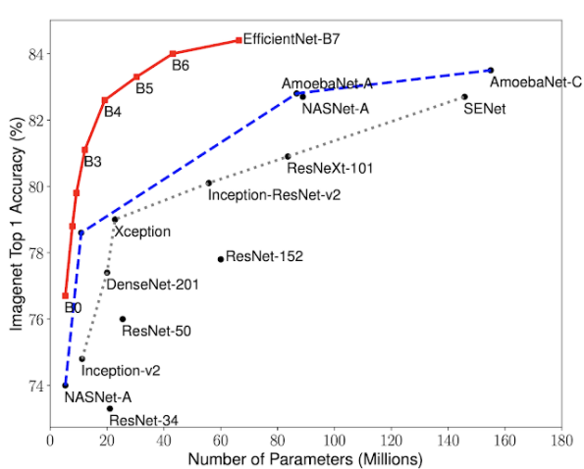
Figure 1.1: Efficient Net Performance

- It shows that for the same FLOPS, the accuracy of EfficientNet than any existing architecture. So, if you were planning to use Inception-v2, you should consider using EfficientNet-B1 instead. Similarly, it is a good idea to consider EfficientNet-B2 if you were planning to use ResNet-50.
- In most real-world applications, people start with a pre-trained model and fine-tune it for their specific application.
- Just because EfficientNet out-performs other networks, does it mean it will out-perform other networks on other tasks?
- The good news is that the authors have done those experiments and shown when the EfficientNet backbone is used, we get better performance in other computer vision tasks as well.
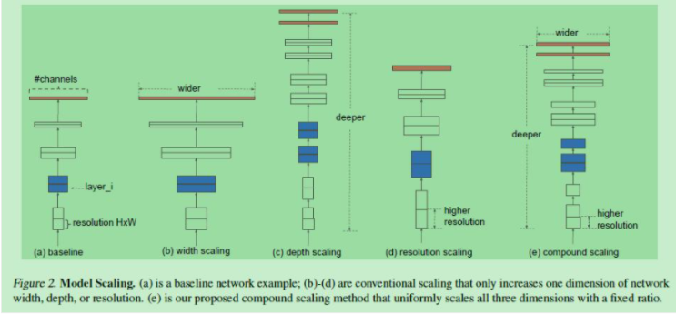
Figure 1.2 :Model Scalling

CNN contrast EfficientNets and existing models, EfficientNet CNN model than the existing model of higher accuracy, higher efficiency, and the amount of its parameters FLOPS have dropped an order of magnitude, EfficientNet-B7 won the best currently on the ImageNet 84.4 % top-1 / 97.1% top-5 accuracy, and the CPU speed is 6.1 times Gpipe inference, the model size and aspect, EfficientNet-B7 is much smaller than other models, while also compared ResNet-50, accurate win a chip rate is (ResNet-50 76.3%, EfficientNet-B4 82.6%)
Our three common network adjustment: receptive field increases w, increased network depth d, increases the size of resolution r, as a schematic view in three ways. Wherein,
(a) Is a baseline network, as may be appreciated that a small network;
(b) To increase the receptive field of network expansion mode;
© Mode network to increase the depth d of the extended network;
(d) Increase the resolution r for the extended network fashion;
(e) As set forth herein mixed mode parameter expansion.
.
Lung cancer can cause severity to the people from any gender or any age. Recent years, even the young and middle aged peoples can able to affect through this disease. At earlier 2016, the World Health Organization collects and produces the reports as most critical cancer type among the top severe diseases like liver fungal cancer, severe gastric cancer, breast cancer, colorectal cancer and stress esophagus cancer and that leads to death because it complex to diagnose and treat the patients. Around 1.59 million of peoples are recorded as dead caused by lung cancer that the report says. In 2018, it affects more number of men compared to the women because it usually caused by chain smoking cigarette and liquor drinking. Even more, this can also be affected through the genetic disorder.
As standards, the lung cancer could be classified into 4 categories; they are as Aden carcinoma, squamous carcinoma, tiny cell cancer and large cell carcinomas. Usually, pathologist can able diagnose the lung cancer and their stages as traditional approach. Almost computed tomography acquisition can be used for identification. However, they diagnose as much as possible, but it may be time consuming and mislead to side effects. This can be avoided through identification of severity based on their stage of lung cancer. It can be identified and predicted through the image processing operations over the CT images. The easy and effective prediction can be done through the implementation of DL techniques. Rather than the machine learning techniques, the DL can be obtained through the large sparse set of dataset representation. It can be effectively predicted through the huge set of training samples.
The shape and texture features can be extracted and used for the implementation of classification. This can be achieved through the fully convolutional neural network (CNN) to obtain the betterment results when compared to the CNNs. In existing, we had this same problem with the high number of convolutions over the implementations. Thus may obtained somewhat improved better results when compared to their existing works. Here, this implementation with proposed candidate generation in fully convolution neural network (FCN) with two phases such as screening and discrimination phase using the tools for detection, type based.

  - Background

In this section, the background knowledge should be learnt and analyzed through the discussions made. Thus, the in-depth details are discussed here. 2.1 Lung Cancer Data Collection Lung cancer is a tumor like disease affected in the spongy like area of lungs and it is leading cause of cancer deaths. Lung cancer disease has probably caused by the smoking, liquor drinking and genetic disorder. This can be categorized based on the tumor cells spread in the lungs and their area. This could be majorly classified into 2 varieties. They are tiny cell lung cancer as well as non-tiny cell lung cancer. Thus the non- tiny cell lung cancer has categorized as squamous carcinoma, Adeno carcinoma as well as huge cell carcinoma.
The FCN is usual CNNs like architecture, where the end layer named fully connected layer is changed to another layer called receptive field layer. Here the discrimination analysis can be done to detect and classify the data through the large context.
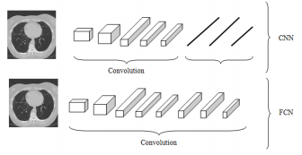
Figure1.3: Conversion of Normal CNN to FCN
The real conversion of normal CNN procedure to fully convolution neural network by replacing the fully connected layer to throughout the convolution layer works.
Over the past several years, image classification and object detection have seen tremendous improvements in accuracy as well as speed thanks to continued research into deep learning and convolutional neural networks (CNNs). The success and improvement found from deep learning is not from improved hardware and more encompassing datasets, but from innovations into model structure. From convolutions into fully connected layers to the addition of dropout layers; to optimization, the approach to deep learning is constantly changing and improving
Over the past several years, image classification and object detection have seen tremendous improvements in accuracy as well as speed thanks to continued research into deep learning and convolutional neural networks (CNNs). The success and improvement found from deep learning is not from improved hardware and more encompassing datasets, but from innovations into model structure. From convolutions into fully connected layers, to the addition of dropout layers, to optimization, the approach to deep learning is constantly changing and improving
  - Related Work
Many computer-aided systems have been developed to help radiologists’ better screen and classify lung cancer. We summarize these systems by the methods they adopt.
1.4 CNN-based Approaches
Ciompi et al. used a convolutional neural network out-of-the-box where they extracted features from a CNN pre-trained on the ImageNet dataset and then applied a simple linear SVM classifier to classify peri-fissural nodules (a benign nodule in the lung with a high 2 false positive rate in lung cancer detection). They used the ensemble of classifiers for 3D slices of an object to obtain the final classifier and compared its performance with a bag of frequencies descriptor with similar accuracy of 86.8%. Hua explored a 3-layer CNN and a Deep Belief Network to approach the problem of nodule classification in computed tomography images. Sun et al. considered three deep learning algorithms: CNN, Deep Belief Networks (DBNs) and Stacked Denoising Auto-encoder (SDAE) to classify nodules. They showed that the performance on down sampled data of the three methods are similar and are around 80%. Shen et al. proposed a hierarchical learning framework using Multi-scale CNN (MCNN). The method captures nodule heterogeneity by extracting features from stacked layers, especially with multi-scale nodule patches.
Neural Network Approaches Many studies have focused on Artificial Neural Network approaches using an optimal combination of features. In particular, Kuruvilla and Gunavathi proposed an artificial neural network approach using statistical parameters like mean, standard deviation, skewness, kurtosis, fifth central moment and sixth central moment to achieve the classification accuracy of 91.1%.
Abdulla et al. used area, perimeter and shape as features to train an artificial neural network for classification of lung cancer with a classification accuracy of 90%. Ada and Kaur carried out a computational procedure that effective sort images into groups by similarity. After using Histogram Equalization and morphology to pre-process the data, they extracted features, applied Principle Component Analysis (PCA) and trained a Neural Network Classifier with a single hidden layer.
Other Image Processing Approaches Image processing techniques have been greatly explored in nodule classification for lung CT images. Numerous studies adopted segmentation, morphological operations and contour filter approaches for better nodule detection. Nathaney and Kalyani developed a system to segment CT images and to classify focal areas in lung region in real time. They applied adaptive threshold method and ROI processing to detect lung cancer with least false negative rate.
Another image processing procedure LCDS is developed by Chaudhary and Singh, where they use smoothing, Gabor filter enhancement and Watershed segmentation in the pre-processing phase and then implemented morphology and colorimetric to extract features such as area, perimeter, and roundness. They compare the statistics of different features to identify the stage of lung cancer for each patient. Sharma and Jindal first applied basic image processing techniques such as erosion, median filter, dilation, outlining, and lung border Extraction to detect lung region and then applied segmentation algorithms to detect cancer nodules and then applied a pre-specified classify to identify cancer nodules.

  - Motivation

Lung cancer is one of the commonest cancers and cause of cancer related deaths all over the world. It accounts for 13 per cent of all new cancer cases and 19 per cent of cancer related deaths worldwide. There were 1.8 million new lung cancer cases estimated to occur in 2012.
With this research we would like to help doctors save time that is otherwise spent in the analysis of the CT Scans, for trying to identify the Lung Cancer. This also indirectly saves precious time of the patient, which can otherwise be used for the treatment. We aim to build a system where the CT Scans be automatically analyzed using the Deep-Convolutional-Neural-Network technology.

CHAPTER 2
LITERATURE SURVEY

2.1 Introduction
The system for detection of lung nodules is proposed here. This chapter presents the basic concepts of the mentioned terms and the work presented by various researchers. Computed tomography (CT) technique was invented and developed by G.N.Hounsfield at the Central Research Laboratories.

Boosted EfficientNet This section clearly describes our methods to improve the performance of EfficientNet on RPCam datasets. We reduce the down sampling scale to maintain appropriate-level semantics information of 7 features. Besides, Feature Fusion (FF) and Attention mechanisms are embedded in this work, which enhance the feature representation ability and increase the response of vital features. There are eight types of EfficientNet from EfficientNet to EfficientNet with an increasing network scale. EfficientNet is selected as our backbone network due to its superior performances than other architectures according to our experimental results on RPCam datasets.

The architecture of boosted EfficientNet: The main building block is MBConv64. Components in red dashed rectangles are different from the original EfficientNet. Images are first sent to some blocks containing multiple convolutional layers to extract image features. Then, these features are weighted by the attention mechanism to improve the response of features contributing to classification. Next, feature fusion mechanism is utilized, enabling features to retain some low-level information. In consequence, images are classified according to those fused features.

Reduce the Down sampling Scale Although EfficientNet has demonstrated competitive functions in many tasks; we observe that there is a disparity in image resolution between the designed model inputs and RPCam datasets. Most models set their input resolution to 224*224 or lager, which maintains the balance between the performance and time complexity. The depth of the network is also designed for adapting the input size. This setting performs well in most well-known baseline image datasets as their resolutions usually are more than 1000*1000. However, the resolution of RPCam datasets is 96*96, which is much smaller than the designed model inputs 300*300. After the EfficientNet processing, the size of the final feature will be 32 times smaller than the input. This feature map is likely to be too abstractive and thus losing low-level features, which may defect the performance of EfficientNet.

To mitigate this problem, we adjust the down-sampling multiple in EfficientNet. Our idea is implemented by modifying the stride of the convolution kernel of EfficientNet even though the receptive filed of convolution kernels might be reduced. However, the reduction influence could be slight since the resolution of inputs is small. To select the best-performed down sampling scale, multiple and elaborate experiments are conducted on the down sampling scale, and strategy outperforms other settings. The size of the feature map in best-performed down sampling scale is 6*6, which is one times larger than the original down sampling multiple. The change of the down sampling scale from is implemented by modifying the stride of the first convolution layer from two to one.

2.2 Research Papers

Efficient Net: Rethinking Model Scaling for Convolutional Neural Networks, Mingxing Tan, Quoc V. Le, arXiv:1905.11946v5 [cs.LG] 11 Sep 2020, Convolutional Neural Networks (ConvNets) are commonly developed at a fixed resource budget, and then scaled up for better accuracy if more resources are available. In this paper, we systematically study model scaling and identify that carefully balancing network depth, width, and resolution can lead to better performance. Based on this observation, we propose a new scaling method that uniformly scales all dimensions of depth/width/resolution using a simple yet highly effective compound coefficient. We demonstrate the effectiveness of this method on scaling up Mobile Nets and ResNet.

Lung Cancer Prediction using Feed Forward Back Propagation Neural Networks with Optimal Features, International Journal of Applied Engineering Research ISSN 0973-4562 Volume 13, Number 1 (2018), Dr. S. Senthil, B. Ayshwarya. Lung disease is the uncontrolled development of strange cells that affect one or both lungs [22]. The main objective is to predict and early detection of lung cancer by using neural network with optimal features. Initially the Lung database are collected and given as input to the system. Then data preprocessing is applied on the input images, for the enhancing the image to get the high contrast images. The enhanced images are trained and tested by neural network compared with sample training database. Particle Swarm Optimization (PSO) is applied to extract the features of the given input images and further process is proceed to detect the lung cancer.

“Lung Cancer Detection Using Image Processing Techniques” Shradhafule, International Research Journal of Engineering and Technology (IRJET), Dec-2017 www.irjet.netThere are various types of cancers i.e. lungs cancer, Breast cancer, blood cancer, throat cancer, brain cancer, tongs cancer, mouth cancer etc. Lung cancer is a disease of abnormal cells multiplying and growing into a tumor. Cancer cells can be carried away from the lungs in blood, or lymph fluid that surrounds lung tissue. In this project we access cancer image into MATLAB collected from different hospitals where present work is going on and this available image was color image we have access that image into MATLAB and followed conversion. Image quality and accuracy is the core factors of this research, image quality assessment as well as improvement are depending on the enhancement stage where low pre-processing techniques is used based on Gabor filter within Gaussian rules. The segmentation and enhancement procedure is used to obtain the feature extraction of normal and abnormal image. Relying on general features, a normality comparison is made. In this research, the main detected features for accurate images comparison are pixels percentage and mask-labelling.

Lung Cancer detection and Classification by using Machine Learning & Multinomial Bayesian Mr. Sandeep A. Dwivedi1 , Mr. R. P. Borse1 , Mr. Anil M. Yametkar, IOSR Journal of Electronics and Communication Engineering (IOSR-JECE),Volume 9, Issue 1, Ver. III (Jan. 2014), Image Processing is a technique to enhance raw images received from cameras/sensors placed on satellites, space probes and aircrafts or pictures taken in normal day-to-day life for various applications. Various techniques have been developed in Image processing during the last four to five decades. Most of the techniques are developed for enhancing images obtained from unmanned space crafts, space probes and military reconnaissance flights. Image Processing systems are becoming popular due to easy availability of powerful personnel computers, large size memory devices, graphics software etc.

Lung Cancer Detection using Machine Learning, International Journal of Engineering Research & Technology (IJERT) ISSN: 2278-0181 Published by, www.ijert.org RTICCT -2019 Conference Proceedings, Vaishnavi. D, Arya. K. S., Devi Abirami. T, M. N. Kavitha.
Automatic defects detection in CT images is very important in many diagnostic and therapeutic applications. Because of high quantity data in CT images and blurred boundaries, tumor segmentation and classification is very hard. This work has introduced one automatic lung cancer detection method to increase the accuracy and yield and decrease the diagnosis time. The goal is classifying the tissues to three classes of normal, benign and malignant. In MR images, the amount of data is too much for manual interpretation and analysis. During past few years, lung cancer detection in CT has become an emergent research area in the field of medical imaging system.

International Journal of Computational Intelligence and Informatics, Vol. 6: No. 2, September 2016 ISSN: 2349-6363 117 Lung Cancer Image Segmentation and Classification using Soft Computing Techniques, G. MadhuBala, I. Laurence Aroquiaraj,The abnormal cells do not develop into healthy lung tissue; they divide rapidly and form tumors. In this paper, the noise that affects the features of CT images, the widespread use of CT image imaging requires the need for developing filter for decreasing noise. Some of the related work is given the most Thresholding based segmentation methods attempt to segment the CT images. Most previous works are prepared to compare different Thresholding based image segmentation algorithms based on characteristics such as correctness, stability with respect to parameter choice and stability with respect to image choice. Performance measure like precision, specificity and false positive rate is used to evaluate the accuracy. It is observed from the experimental evaluation that the performance of ANN is better than that of individual classifiers of Lung image data sets.

(IJACSA) International Journal of Advanced Computer Science and Applications, Vol. 8, No. 8, 2017 Lung Cancer Detection and Classification with 3D Convolutional Neural Network (3D-CNN), WafaaAlakwaa, Mohammad Nassef, AmrBadr, This paper demonstrates a computer-aided diagnosis (CAD) system for lung cancer classification of CT scans with unmarked nodules, a dataset from the Kaggle Data Science Bowl, 2017. Thresholding was used as an initial segmentation approach to segment out lung tissue from the rest of the CT scan. Thresholding produced the next best lung segmentation. The initial approach was to directly feed the segmented CT scans into 3D CNNs for classification, but this proved to be inadequate. Instead, a modified U-Net trained on LUNA16 data (CT scans with labeled nodules) was used to first detect nodule candidates in the Kaggle CT scans. The U-Net nodule detection produced many false positives, so regions of CTs with segmented lungs where the most likely nodule candidates were located as determined by the U-Net output were fed into 3D Convolutional Neural Networks (CNNs) to ultimately classify the CT scan as positive or negative for lung cancer. The 3D CNNs produced a test set Accuracy of 86.6%. The performance of our CAD system outperforms the current CAD systems in literature which have several training and testing phases that each requires a lot of labeled data, while our CAD system has only three major phases (segmentation, nodule candidate detection, and malignancy classification), allowing more efficient training and detection and more generalizability to other cancers.

A Review of Lung cancer Prediction System using Data Mining Techniques and Efficient Net¸International Journal of Applied Engineering Research ISSN 0973-4562 Volume 12, Number 10 (2017), H Bharathi, 1TS Arulananth
The approach that is followed for the prediction technique is depend on systematic study of the statistical factors, symptoms and associated with Lung cancer. Non-clinical symptoms and risk factors are some of the generic indicators of the cancer diseases. Initially parameters for the predignosis are collected by interacting with the pathological, clinical and medical oncologists. The objective of this paper is to summarize various review and technical articles on diagnosis of lung cancer. It gives overview of the current research being carried out on various lung cancer datasets using the data mining techniques and to enhance the lung cancer diagnosis.

Lung cancer detection using image processing techniques” Shradhafule, International Research Journal of Engineering and Technology (IRJET) e-ISSN: 2395-0056 Volume: 04 Issue: 12 | Dec-2017
An image processing technique is built to detect diseases at early stage of cancer so the patient can take the treatment at early stages. The time factor is major factor to discover the abnormal tissue in target x-ray images. The accuracy and the quality of image is one the major core factor of this research. Image quality as well as image enhancement stage were adopted as low pre-processing techniques based on Gabor filter. This technique is efficient for segmentation stage so the region of interest for feature extraction obtaining. On the basis of general features a normality and abnormality comparison is made. The main feature for detection of accurate image comparison are pixel percentage and mask labeling which gives us the indication that the process of detection this disease plays a very important and essential role to avoid serious stages and to reduce its percentage distribution in the world. To obtain more accurate results we three stages: Image Enhancement stage, Image Segmentation stage and Features Extraction stage.

Deep convolutional neural networks for multi-planar lung nodule detection: Improvement in small nodule identification, SunyiZhenga) and Ludo J. Cornelissen, Xiaonan Cui, Xueping Jing, 30 November 2020; f American Association of Physicists in Medicine,
Early detection of lung cancer is of importance since it can increase patients’ chances of survival. To detect nodules accurately during screening, radiologists would commonly take the axial, coronal, and sagittal planes into account, rather than solely the axial plane in clinical evaluation. Inspired by clinical work, the paper aims to develop an accurate deep learning framework for nodule detection by a combination of multiple planes. Methods: The nodule detection system is designed in two stages, multi-planar nodule candidate detection, multi-scale false positive (FP) reduction. At the first stage, a deeply supervised encoder–decoder network is trained by axial, coronal, and sagittal slices for the candidate detection task. All possible nodule candidates from the three different planes are merged. To further refine results, a three dimensional multi-scale dense convolutional neural network that extracts multi-scale contextual information is applied to remove non-nodules. In the public LIDC-IDRI dataset, 888 computed tomography scans with 1186 nodules accepted by at least three of four radiologists are selected to train and evaluate our proposed system via a tenfold cross-validation scheme. The free-response receiver operating characteristic curve is used for performance assessment.

2.3 Summary

Lung cancer is a disease of uncontrolled cell growth in tissues of the lung. Since lung cancer is one of the leading causes of death, early detection of malignant tumours is imperative for a successful recovery. In general, early stage lung cancer diagnosis techniques mainly utilize X-ray chest films, CT, MRI, etc. Computed tomography (CT) produces a series of cross-sectional images covering a part of the human body. For our case specifically, we will focus on the thoracic region. Visually identifying and examining these images for potential abnormalities is a challenging and time consuming task due to the large amount of information that needs to be processed, and the short amount of time given. The subject of medical image mining is currently an up and coming topic and shows a lot of research potential in the area of computational intelligence. By auto-analyzing a patient’s records and images through data mining and image processing techniques, we would reduce the risk of human error in nodule detection. By applying a combination of techniques in data pre-processing, feature extraction, and classification, we ultimately seek to increase the accuracy rate of cancer detection, while simultaneously reducing the false positive diagnosis rate. In this project, we propose to use deep artificial neural network architecture, which is a combination of CNN along with RNN for the fully-automated detection of pulmonary nodules in CT scans. The architecture of the VGG16 convolutional neural network is trained to distinguish pixels across images, and can be utilized in our case to extract nodule information. Our project will demonstrate that by leveraging these techniques, we substantially increase the sensitivity to detect pulmonary nodules, without inflating the false positive rate.

CHAPTER 3
RESEARCH METHODOLOGY

3.1 Aim& Objectives

- Self-Learning: To understand the CT scan technology and how the images formed can be used to identify the cancerous nodule.
- Self-Learning: To understand the deep learning algorithms and the working principles of convolution techniques in deep neural networks.
- Development: Develop CNN based Lung Cancer Detection and Nodule Classification algorithm.
- Research: To research various CNN based deep learning architectures, and their detection and classification performance on the dataset

3.2 Problem Statement
The project integrates different topics in Computer Science to try and solve a real world problem in the medical domain. The project consists of CNN and software development to deliver a proof of concept. The application is a lung cancer detection system to help doctors make better and informed decisions when diagnosing lung cancer using efficient Net.

3.3 Need of The study

The system will be trained with large datasets to diagnose the type of cancer with its size and shape. The overall accuracy of the system can be improved using Convolutional Neural Network and also by improving the hidden neurons with deep network.

3.4 Scope of study

- Processing of noisy input image using filter and segmentation
- Morphological operations on CT image. The cancer affected lungs region can be observed in the final output image to CT input image provided. The proposed method can also be applied to some other cancer types like breast cancer, skin cancer etc. Also it finds its application in the medical research as well.

- 3.5 Methodology
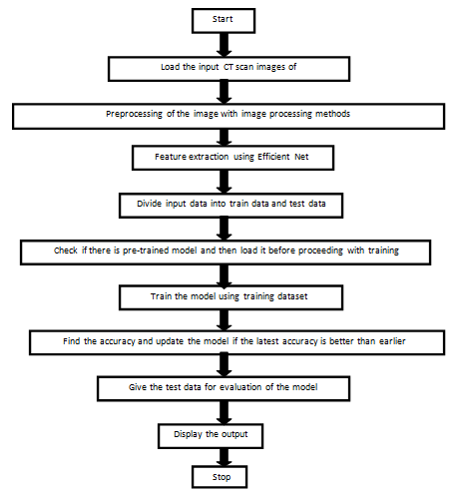

CHAPTER 4
SYSTEM DESIGN

4.1 System Architecture

System architecture of implementation work; usually the images can be pre-processed before the indulging with the proposed implementation. In pre-processing process, initially the images can be converted into the gray scale to perform the image processing methods. After that the image should be denoised through Gaussian Filter to make filtered and pre-processed image.

It is having the difference of usual fully convolutional neural network with the two different phases. Thus the system model consists of three sequences of different layers to make the effective classification such as convolution phase, screening phase and discrimination phase. It can be divided into three important phases after that the pre-processing technique. In first phase, the convolution layer can be done. In this phase, the sub-sampling and convolution processes are done with the variations in the pixel size. In screening phase, it cats as a decoder and also score volume also calculated here to make candidate generation. Finally, in discrimination phase, the lung cancer can be detected and stage can be classified through the fine and coarse segmentation.

Algorithm: Proposed Efficient Net based lung classification
[1] Initiate with input image
[2] Pre-process the image I with two main processes
[3] Convert the image into Lung as gray scale
[4] De-noise the image Lung as in using Gaussian Filter
[5] Apply convolution phase with these attributes

a. Perform 3 x 3 convolution with different 32, 64, 128, 256 ReLU functions
b. Perform 2 x 2 Max Pooling as sub sampling

[6] Applying Screening phase
a. Perform 32 x 32 transpose convolutional.
b. Prevents the over-fitting

[7] Apply discrimination phase

a. Select the convolution coordinates from previous input
b. Computes the class scores
c. Matching with the 1-D array of size
d. Define the classes from the array
e. Detection of stages through the variations in pixels

Thus the above algorithm is used to perform the effective classification of lung cancer with three different phases. To improve the efficiency the transpose convolution matrix attributes can be hiked and array classes can be accurately defined and stages are detected.

4.2 Algorithm

STEP-1: Collect the lung cancer images from respective cancer Dataset.
STEP-2: Analyze the dataset for variety of lung cancer’s information present in the database.
STEP-3: Prepare the methodology for lung cancer detection model development and training-&-testing.
STEP-4: Prepare the dataset, with data augmentation for training.
STEP-5: Design the Deep CNN architecture to identify the Lung Cancer in the CT scan image. Train the model.
STEP-6: Train the CNN model and measure its performance. Finetune the algorithm if necessary
STEP-7: Create the system for using the trained DCNN model to identify lung cancer in new images.

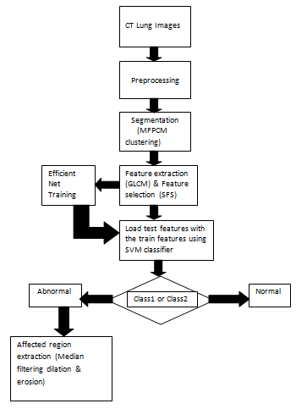

4.3 Software & Hardware Requirement Specification
- Anaconda
- Python3.0
- All Libraries of Python
- Processor: 1 gigahertz (GHz) or faster processor or SoC.
- RAM: 1 gigabyte (GB) for 32-bit or 2 GB for 64-bit.
- Hard disk space: 16 GB for 32-bit OS 20 GB for 64-bit OS

4.4 Assumptions and Dependencies
Assumptions:
- User must have basic knowledge of computer.
- Must be familiar basic with the Software and their knowledge of basic functions of python
Dependencies:
- User and Administrators will communicate among themselves while executing the application.
- Escalation mechanism is limited to administrator only.
4.5 Project Timeline Chart
Months/ Activity | July | Aug | Sept | Oct | Nov | Dec | Jan | Feb | March | April | May 2021
Reference Papers
Problem statement
Find out Techniques
Search For Algorithm
Flow chart and steps confirmed
Start Our coding
G
H
I
J

CHAPTER 5
UML DIAGRAMS

5.1 Data Flow Diagrams
5.1.1 Data Flow Level-0

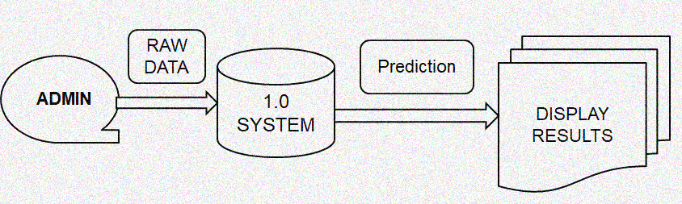

5.1.2 Data Flow Level-1

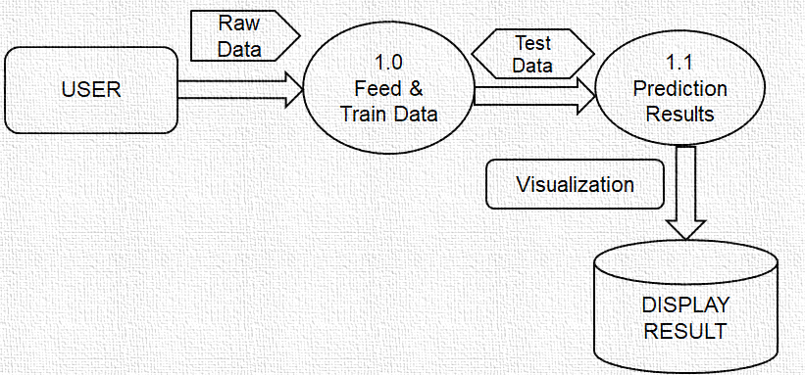

5.1.3 Data Flow Level-2
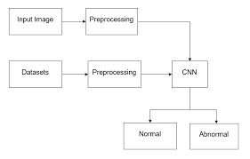
5.2 Class Diagram
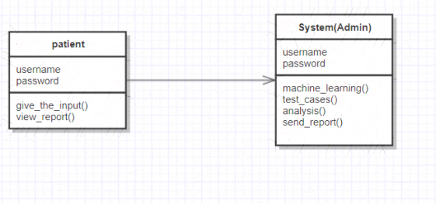

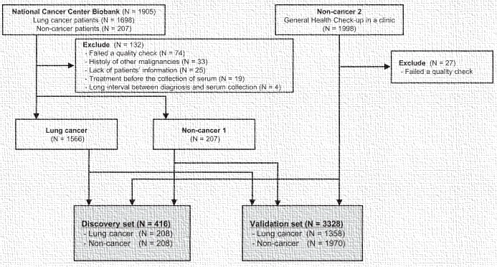

5.3 Activity Diagram

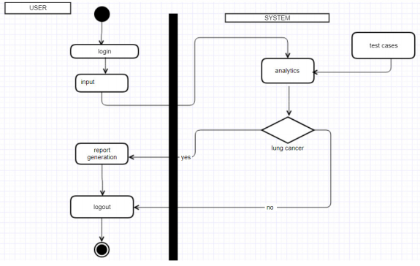

5.4 Sequence Diagram
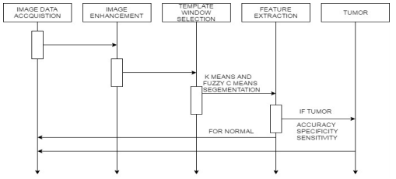
If Cancer
Cancer

5.5 Work Flow Diagram
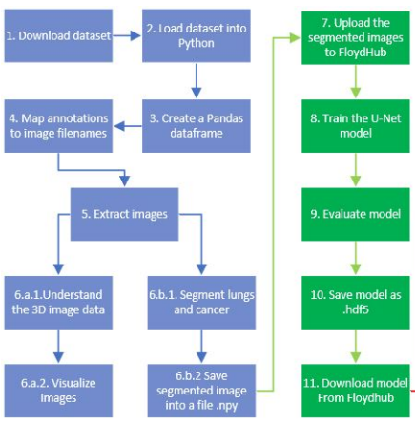

5.6 Use Case Diagram
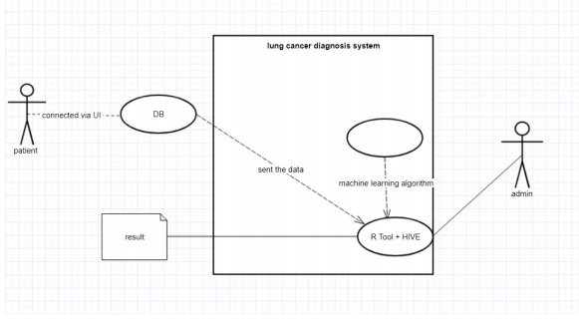

5.7 User Interfacing Diagram
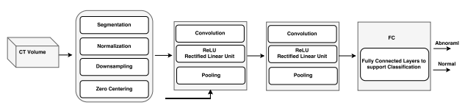

CHAPTER 6
DATABASE DESCRITION

6.1 DATASET

Dataset Description

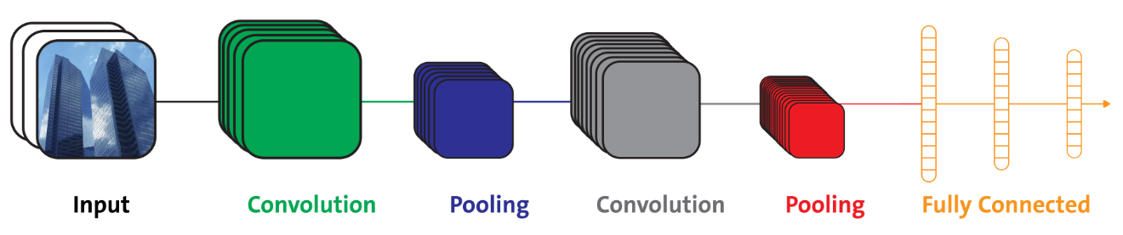
Fig6.1: Architecture of CNN.

A convolutional layer that extracts features from a source image
A pooling layer that down samples each feature to reduce its dimensionality and focus on the most important elements.
A fully connected layer that flattens the features identified in the previous layers into a vector, and predicts probabilities that the image belongs to each one of several possible labels

Convolutional Neural Networks (CNN) is a deep model that performs well with a variety of tasks such as image classification, natural language processing, and signal processing. CNNs are explicitly designed to deal with multi-dimensional input and overcome the high number of parameters that are requested by standard FNN. For example, a single RGB image of size 64x64, in an FNN would require: 64 · 64 · 3 = 12288 neurons as input. The issues that arise when the FNN is over parameterized are the following:

A huge number of input neurons will require more layers at a high computation cost and time required for training.
Over parameterization is a symptom of over fitting: in the specific case of an image, the FNN would behave too meticulous since it will take into account each single pixel.

Convolutional layers convolve the input and pass its result to the next layer. This is similar to the response of a neuron in the visual cortex to a specific stimulus.Each convolutional neuron processes data only for its receptive. Although fully connected feed forward neural networkscan be used to learn features as well as classify data, it is not practical to apply this architecture to images. A very high number of neurons would be necessary, even in shallow (opposite of deep) architecture, due to the very large input sizes associated with images, where each pixel is a relevant variable.
When programming a CNN, the input is a tensor with shape (number of images) x (image height) x (image width) x (input channels). Then after passing through a convolutional layer, the image becomes abstracted to a feature map, with shape (number of images) x (feature map height) x (feature map width) x (feature map channels). A convolutional layer within a neural network should have the following attributes:
- Convolutional kernels defined by a width and height
- The number of input channels and output channels
- The depth of the Convolution filter the input channels must be equal to the number channels of the input feature map.
Max pooling

Combining TDNNs with max pooling in order to realize a speaker independent isolated word recognition system; in their system they used several TDNNs per word, one for each syllable. The results of each TDNN over the input signal were combined using max pooling and the outputs of the pooling layers were then passed on to networks performing the actual word classification [18].

❖LeNet-5

LeNet-5, a pioneering 7-level convolutional network that classifies digits, was applied by several banks to recognize hand-written numbers on checks digitized in 32x32 pixel images [14,15]. The ability to process higher resolution images requires larger and more layers of convolutional neural networks, so this technique is constrained by the availability of computing resources.

➢3D volumes of neurons: The layers of a CNN have neurons arranged in 3 dimensions: width, height and depth where each neuron inside a convolutional layer is connected to only a small region of the layer before it, called a receptive field. Distinct types of layers, both locally and completely connected, are stacked to form CNN architecture [14, 15,17].

➢Local connectivity: following the concept of receptive fields, CNNs exploit spatial locality by enforcing a local connectivity pattern between neurons of adjacent layers [5, 6]. The architecture thus ensures that the learned "filters" produce the strongest response to a spatially local input pattern. Stacking many such layers leads to non-linear filters that become increasingly global i.e. responsive to a larger region of pixel space) so that the network first creates representations of small parts of the input, then from them assembles representations of larger areas [23, 24].

➢Shared weights: In CNNs, each filter is replicated across the entire visual field. These replicated units share the same parameterization (weight vector and bias) and form a feature map. This means that all the neurons in a given convolutional layer respond to the same feature within their specific response field. Replicating units in this way allows for the resulting feature map to be equivariant under changes in the locations of input features in the visual field, i.e. they grant translational equivariance [15].

➢Pooling: In a CNN's pooling layers, feature maps are divided into rectangular sub-regions, and the features in each rectangle are independently down-sampled to a single value, commonly by taking their average or maximum value [16,19]. In addition to reducing the sizes of feature maps, the pooling operation grants a degree of translational invariance to the features contained therein, allowing the CNN to be more robust to variations in their positions.

The convolutional layer is the core building block of a CNN. The layer's parameters consist of a set of learnable filters, which have a small receptive field, but extend through the full depth of the input volume.
During the forward pass, each filter is convolved across the width and height of the input volume, computing the dot product between the entries of the filter and the input and producing a 2-dimensional activation map of that filter. As a result, the network learns filters that activate when it detects some specific type of feature at some spatial position in the input

❖pooling layer:
Another important concept of CNNs is pooling, which is a form of non-linear down-sampling. There are several non-linear functions to implement pooling among which max pooling is the most common. It partitions the input image into a set of non-overlapping rectangles and, for each such sub-region, outputs the maximum.

The pooling layer operates independently on every depth slice of the input and resizes it spatially. The most common form is a pooling layer with filters of size 2×2 applied with a stride of 2 down samples at every depth slice in the input by 2 along both width and height. In addition to max pooling, pooling units can use other functions, such as average pooling or pooling. Average pooling was often used historically but has recently fallen out of favour compared to max pooling, which performs better in practice.
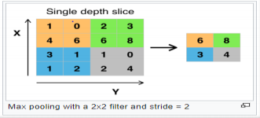
Figure 6.2: Pooling Layer
6.2 Future Scope
We can implement this technique on some more images. Increasing the number of images used for the process can improve the accuracy.
Also MRI, X-ray, PET images can be considered for this technique. Comparison can be done for all these images. So one can justify which types of images gives better result for lung cancer detection

6.3 Advantages & Disadvantages

Advantages
The current research is extremely helpful to many students who would like to implement the findings into their projects and as well as to do further research. The advantage of these research findings is that it also helps in improving the detection of cancer at an early stage and to reduce the detection error.
Disadvantages
The disadvantages are that usually the data training set is very huge which increases the time taken to train. In order to obtain a beyond-average accuracy, we are requird to use an extremely large data set in order to train the model. Although it is time consuming for the code to train the network, it is a one-time process that can be redone if there are new types of cancers that need to be trained.

Chapter -7
Code for Prepare , Train ,test and Reshape the module

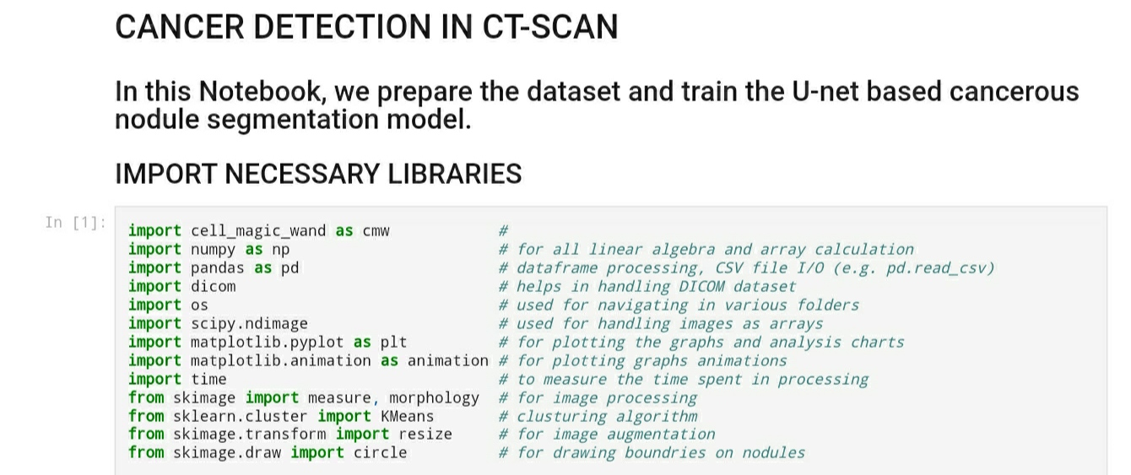

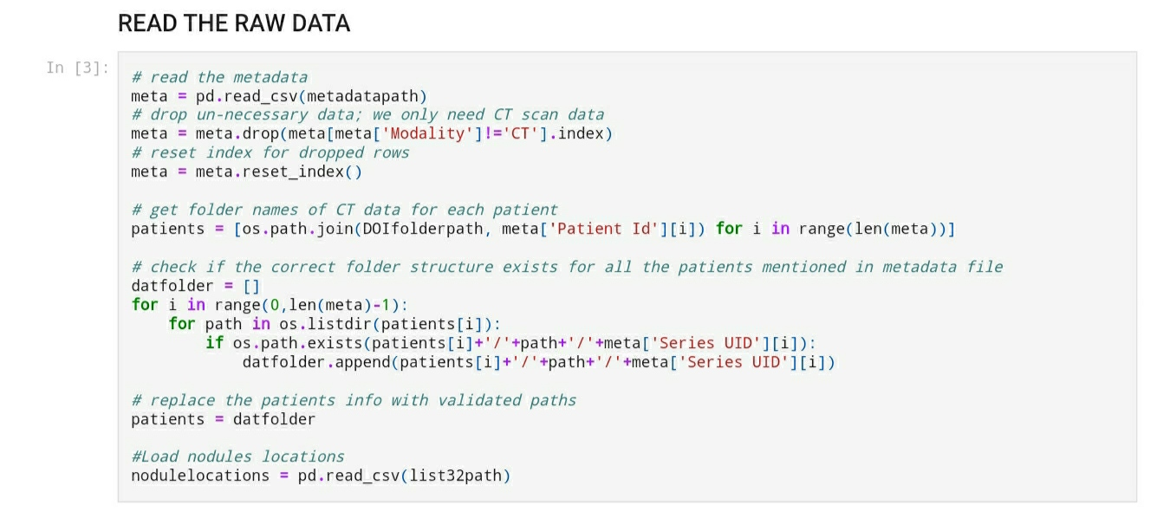

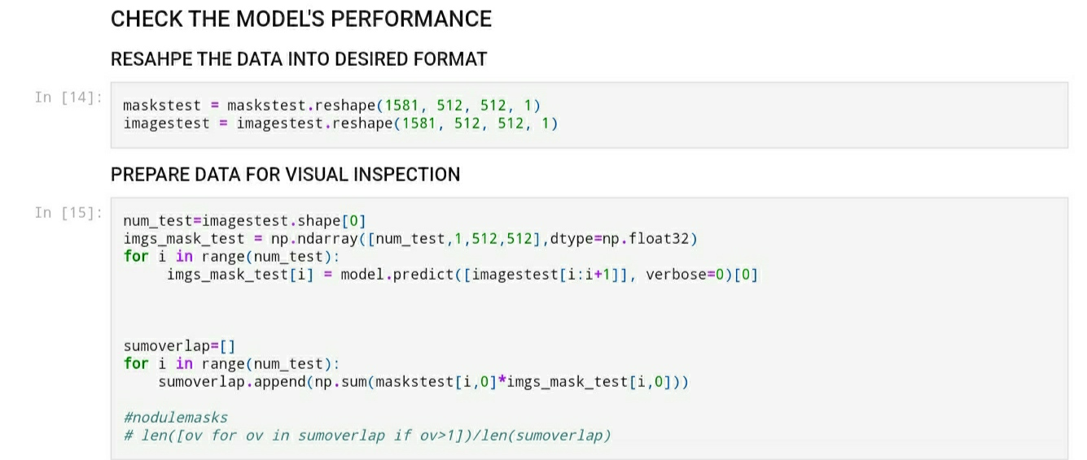

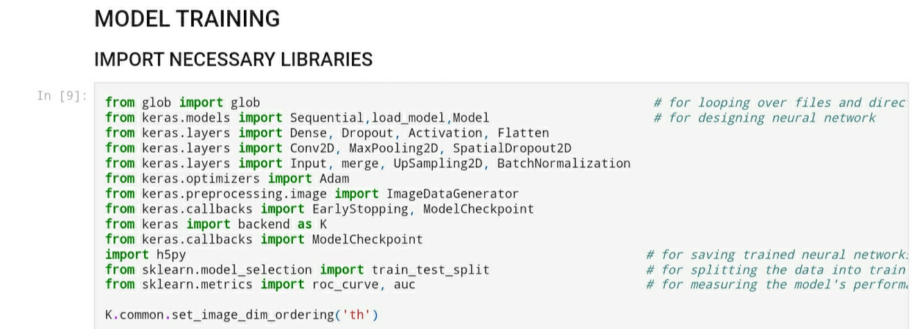

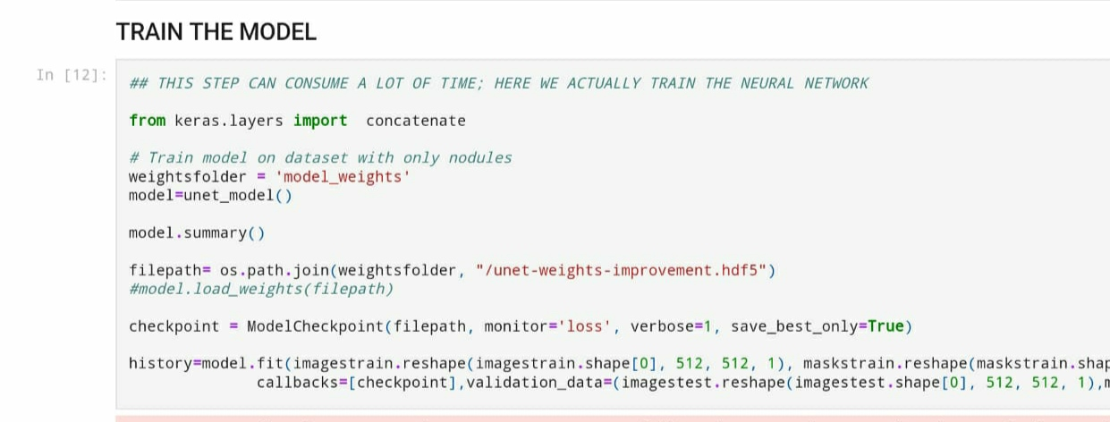

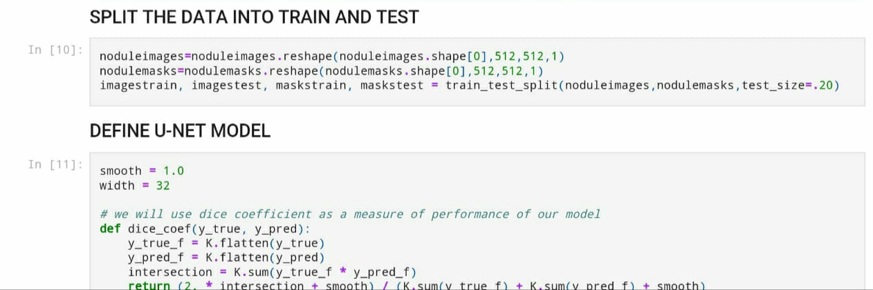

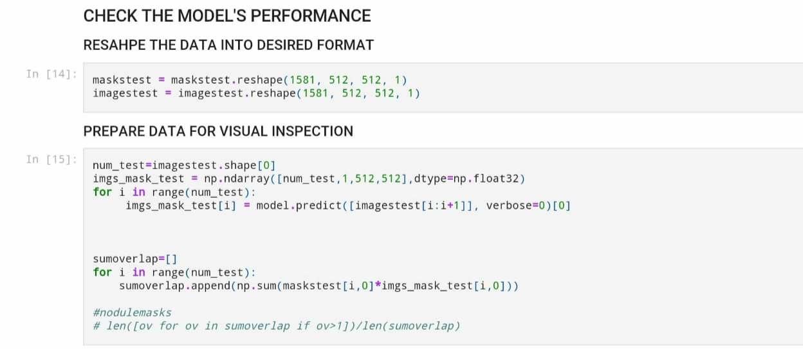

Chapter-8
Implemented Input-Output

Input-

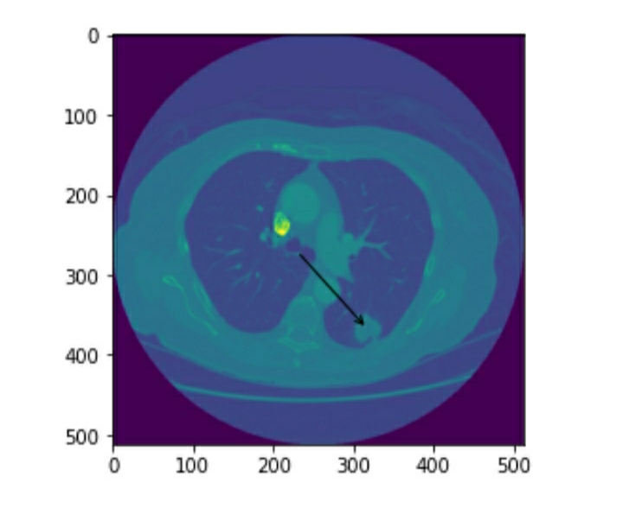

Output
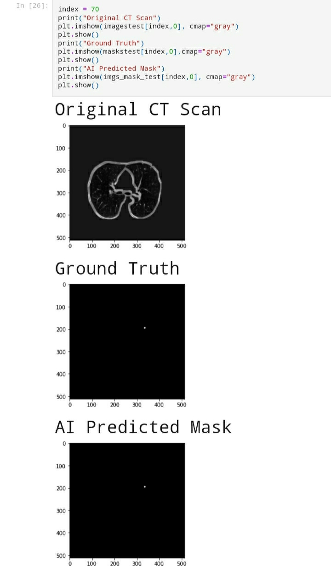

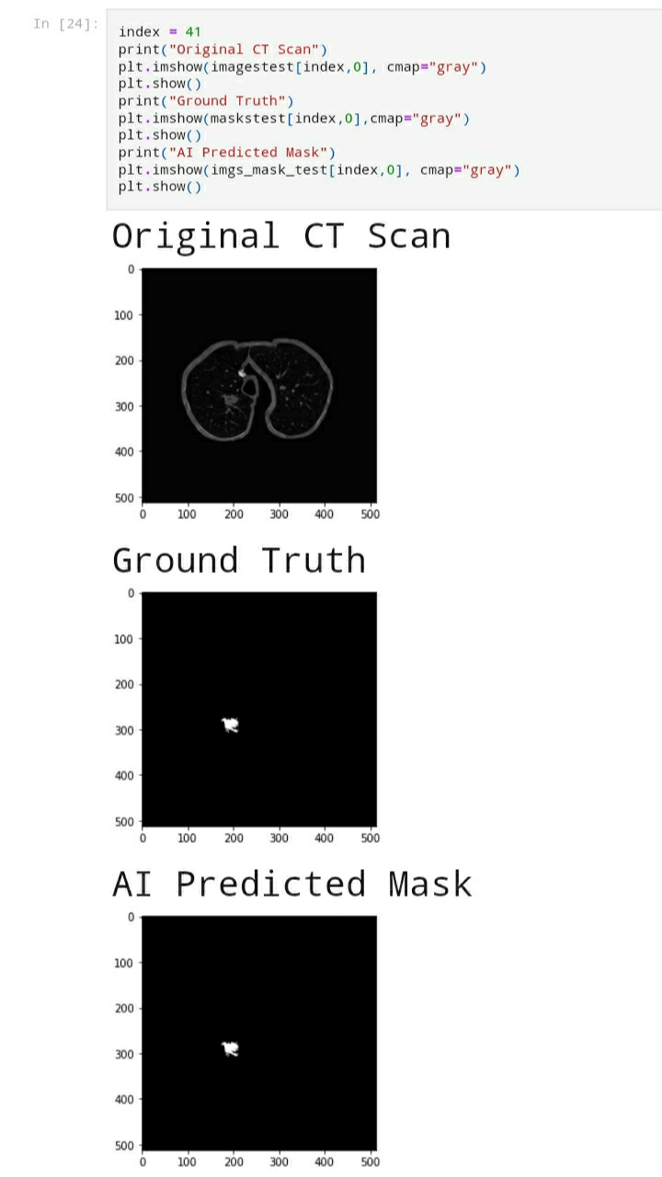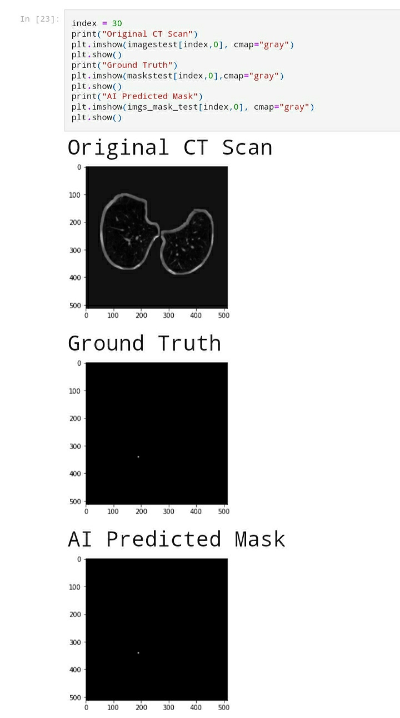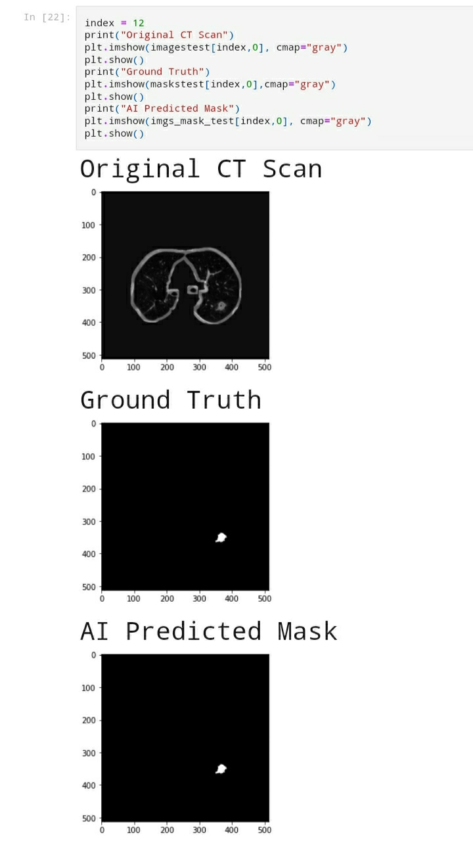

CHAPTER 9
CONCLUSION

The model higher accuracy using the dice coefficient on the training set. The dice coefficient is much lower on the training set however the confusion matrix outputs a high true and false positive rate on a set that contains positive and negative samples. This indicates that the model is great at distinguishing between CT scan slices with no cancer nodules compared to the ones with cancer.
I believe with more hyper-parameter tuning and model training the accuracy could be increased.

REFERENCES
- World Health Organization. (2020). WHO report on cancer: setting priorities, investing wisely and providing care for all.
- Wang, S., Dong, L., Wang, X., & Wang, X. (2020). Classification of pathological types of lung cancer from CT images by deep residual neural networks with transfer learning strategy. Open Medicine, 15(1), 190-197.
- Asuntha, A., & Srinivasan, A. (2020). Deep learning for lung Cancer detection and classification. Multimedia Tools and Applications, 1- 32.
- EfficientNet: Rethinking Model Scaling for Convolutional Neural Networks Mingxing Tan 1 Quoc V. Le, arXiv:1905.11946v5 [cs.LG] 11 Sep 2020
- Tan, M., & Le, Q. V. (2019). Efficientnet: Rethinking model scaling for convolutional neural networks. arXiv preprint arXiv:1905.11946.
- Zhang, X., Zhou, X., Lin, M., and Sun, J. Shufflenet: An extremely efficient convolutional neural network for mobile devices. CVPR, 2018.
- Mario Buty1, Ziyue Xu1 , Mingchen Gao” Characterization of Lung Nodule Malignancy using Hybrid Shape and Appearance Features”(2017)
- Teramoto, A., Tsukamoto, T., Kiriyama, Y., & Fujita, H. (2017). Automated classification of lung cancer types from cytological images using deep convolutional neural networks. BioMed research international, 2017.
- Song, Q., Zhao, L., Luo, X., & Dou, X. (2017). Using deep learning for classification of lung nodules on computed tomography images. Journal of healthcare engineering, 2017.
- Zhang, X., Li, Z., Loy, C. C., and Lin, D. Polynet: A pursuit of structural diversity in very deep networks. CVPR, pp. 3900–3908, 2017.
- Arnaud A. A. Setio, Francesco Ciompi, Geert Litjens, Paul Gerke, Colin Jacobs, Sarah J. van Riel, Mathi”Pulmonary nodule detection in CT images: false positive reduction using multi-view convolutional networks”(2016).
- Szegedy, C., Vanhoucke, V., Ioffe, S., Shlens, J., and Wojna, Z. Rethinking the inception architecture for computer vision. CVPR, pp. 2818–2826, 2016.

